**YAMMER CASE STUDY**

**Case 1 Investigating a Drop in User Engagement**

Dip in retention / weekly active users from 1442 in July 28 2014 to 1194 Aug 25 2014

A weekly active user is one who logged at least 1 engagement the week starting on that date. Engagement is a server call by interacting with the product more specifically a login per the table.

**Getting Oriented - Possible causes of the dip and how to test**

The dip may be caused by more current users not engaging in a server call and not enough new users engaging in a server call or that current users are not engaging in a server call and we have no new users. Identify users week to week and see how many new users there are.

Users may be using the product and simply not performing activities that require a server call. Understand what constitutes a server call and if the user can be using the product but not performing an activity that requires a server call.

Data gathering mechanism is broken. The server calls are not getting recorded by our system. Test the data gathering system to ensure activities associated with server calls are being performed

There may be a one-time event that caused a surge in users such as a trade show, SEO push or other action.

**What I do Not Know**

We do not know how many server calls are being done for each count. The 1194 may have 10,000 calls while the 1442 only have 1442 (1 call each)

We do not know how long each of the engagements were. The 1194 may have spent an average of hour each on Yammer while the 1442 maybe only spent 1 minute each.

We do not know if the users from week to week are the same or different

We do not know if there was a one time event that caused a surge in users.

**Digging into the Data / Queries**

View all the table data

SELECT * FROM tutorial.yammer_users LIMIT 100

SELECT * FROM tutorial.yammer_events LIMIT 100

SELECT * FROM tutorial.yammer_emails LIMIT 100

SELECT * FROM benn.dimension_rollup_periods LIMIT 100

QUERY used to create chart

SELECT DATE_TRUNC('week', e.occurred_at),

COUNT(DISTINCT e.user_id) AS weekly_active_users

FROM tutorial.yammer_events e

WHERE e.event_type = 'engagement'

AND e.event_name = 'login'

GROUP BY 1

ORDER BY 1

**Summary**

The dates to focus on are from July 28th which represents the peak login engagement activity to August 25th which represents the end of our data. Based on the queries below the next steps to take are to

1. New users are joining, examine current user activity and see what may be causing drop off

2. Investigate email clickthroughs and see if they are broken or why users are not clicking through.

3. Examine User Type 1 and 2 and see why they continue to drop off while user type 3 does not

4. Examine English, French, German and Japanese emails and application to see if there are any bugs or mis-translations

5. Examine the mobile and tablet applications to see if there are any bugs or reason why they have higher drop off.

**Actions**

See if users are active across different dates

**Activated users by week**

SELECT DATE_TRUNC('week',activated_at) AS week,

COUNT(CASE WHEN activated_at IS NOT NULL THEN user_id ELSE NULL END) AS activated_users

FROM tutorial.yammer_users

WHERE activated_at >= '2014-04-28'

AND activated_at < '2014-09-01'

GROUP BY 1

ORDER BY 1



There's a decrease of new user activity between July 28th and August 4th that is worth looking into. Other than that new user activity is generally increasing so the dip is likely in current users.

**Email activity by week**

SELECT DATE_TRUNC('week', occurred_at) AS week,

COUNT(CASE WHEN action = 'sent_weekly_digest' THEN user_id ELSE NULL END) AS weekly_emails,

COUNT(CASE WHEN action = 'sent_reengagement_email' THEN user_id ELSE NULL END) AS reengagement_emails,

COUNT(CASE WHEN action = 'email_open' THEN user_id ELSE NULL END) AS email_opens,

COUNT(CASE WHEN action = 'email_clickthrough' THEN user_id ELSE NULL END) AS email_clickthroughs

FROM tutorial.yammer_emails

GROUP BY 1

ORDER BY 1

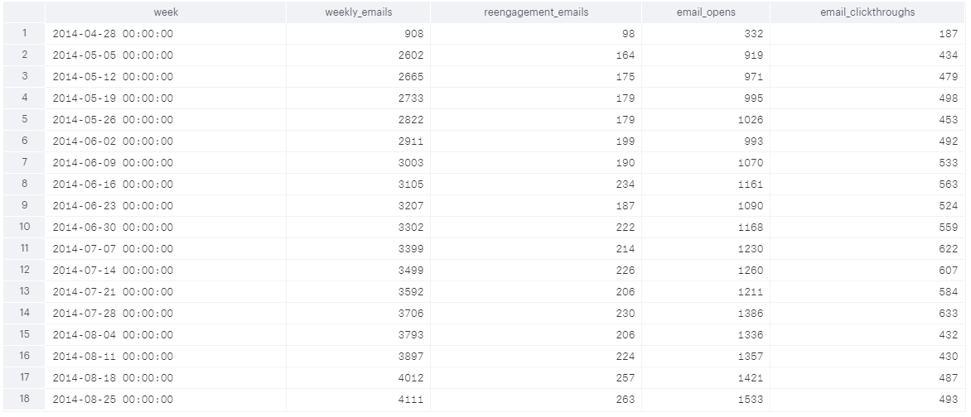

Weekly email levels and emails being opened are steadily increasing so that does not appear to be the cause. Reengagement_emails show a 1 time dip from July 28th to August 11th. Clickthroughs have dropped significantly after July 28th. Recommend Investigating if the clickthroughs are broken.

**User type by week**

SELECT DATE_TRUNC('week', occurred_at) AS week,

COUNT(CASE WHEN user_type = '1' THEN user_id ELSE NULL END) AS type_1,

COUNT(CASE WHEN user_type = '2' THEN user_id ELSE NULL END) AS type_2,

COUNT(CASE WHEN user_type = '3' THEN user_id ELSE NULL END) AS type_3

FROM tutorial.yammer_events

WHERE event_type = 'engagement'

AND event_name = 'login'

GROUP BY 1

ORDER BY 1

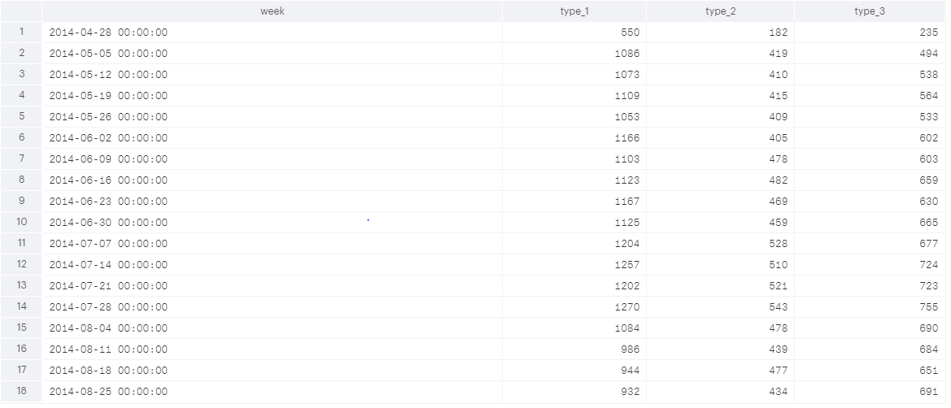

User type 3 has a smallest drop (8.6% vs. 12% & 14.6% from 07-28 to 08-04 and then appears to stabilize. User type 1 and 2 look to continuously be decreasing. I would investigate why this is the case and what is the difference between type 3 and type 1 & 2.

**Country by week**

SELECT location,

COUNT(*) FROM tutorial.yammer_events

WHERE event_type = 'engagement'

AND event_name = 'login'

GROUP BY 1

ORDER BY 2 DESC

LIMIT 20

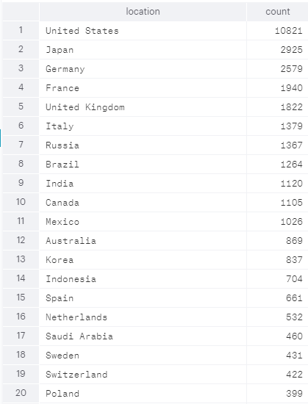

There's a significant drop off after the first 11 countries. Will do a week to week evaluation of the 11 countries

SELECT DATE_TRUNC('week', occurred_at) AS week,

COUNT(CASE WHEN location = 'United States' THEN user_id ELSE NULL END) AS usa,

COUNT(CASE WHEN location = 'Japan' THEN user_id ELSE NULL END) AS japan,

COUNT(CASE WHEN location = 'Germany' THEN user_id ELSE NULL END) AS germany,

COUNT(CASE WHEN location = 'France' THEN user_id ELSE NULL END) AS france,

COUNT(CASE WHEN location = 'United Kingdom' THEN user_id ELSE NULL END) AS uk,

COUNT(CASE WHEN location = 'Italy' THEN user_id ELSE NULL END) AS italy,

COUNT(CASE WHEN location = 'Russia' THEN user_id ELSE NULL END) AS russia,

COUNT(CASE WHEN location = 'Brazil' THEN user_id ELSE NULL END) AS brazil,

COUNT(CASE WHEN location = 'India' THEN user_id ELSE NULL END) AS india,

COUNT(CASE WHEN location = 'Canada' THEN user_id ELSE NULL END) AS canada,

COUNT(CASE WHEN location = 'Mexico' THEN user_id ELSE NULL END) AS mx

FROM tutorial.yammer_events

WHERE event_type = 'engagement'

AND event_name = 'login'

GROUP BY 1

ORDER BY 1

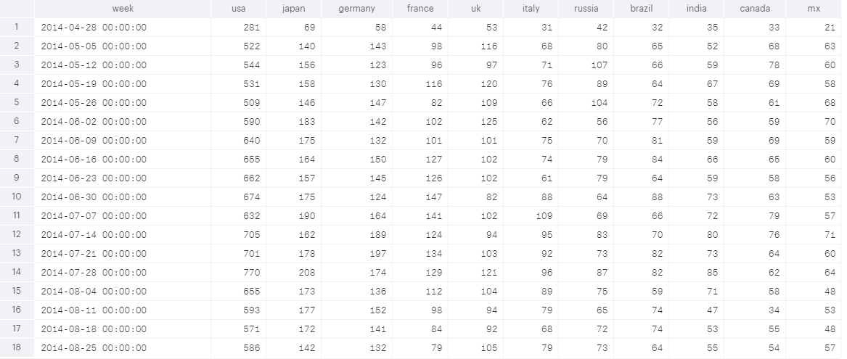

There does not appear to be any country specific cause of the drop off in login activity.

**User Company by week**

SELECT COUNT(DISTINCT u.company_id)

FROM tutorial.yammer_events e

JOIN tutorial.yammer_users u

ON e.user_id = u.user_id

WHERE e.event_type = 'engagement'

AND e.event_name = 'login'

AND u.activated_at IS NOT NULL

4453 unique Company IDs from April 28th to September 1st. This is too many company IDs to evaluate meaningfully without more data defining the company IDs. Even limiting the dates to July 28th on with e.occured_at >= '2014-07-28' results in 2338 companies

**User Language by week**

SELECT language FROM tutorial.yammer_users GROUP BY 1

12 languages

SELECT DATE_TRUNC('week', e.occurred_at) AS week,

COUNT(CASE WHEN u.language = 'japanese' THEN e.user_id ELSE NULL END) AS japanese,

COUNT(CASE WHEN u.language = 'chinese' THEN e.user_id ELSE NULL END) AS chinese,

COUNT(CASE WHEN u.language = 'italian' THEN e.user_id ELSE NULL END) AS italian,

COUNT(CASE WHEN u.language = 'english' THEN e.user_id ELSE NULL END) AS english,

COUNT(CASE WHEN u.language = 'spanish' THEN e.user_id ELSE NULL END) AS spanish,

COUNT(CASE WHEN u.language = 'portugese' THEN e.user_id ELSE NULL END) AS portugese,

COUNT(CASE WHEN u.language = 'arabic' THEN e.user_id ELSE NULL END) AS arabic,

COUNT(CASE WHEN u.language = 'korean' THEN e.user_id ELSE NULL END) AS korean,

COUNT(CASE WHEN u.language = 'indian' THEN e.user_id ELSE NULL END) AS indian,

COUNT(CASE WHEN u.language = 'russian' THEN e.user_id ELSE NULL END) AS russian,

COUNT(CASE WHEN u.language = 'french' THEN e.user_id ELSE NULL END) AS french,

COUNT(CASE WHEN u.language = 'german' THEN e.user_id ELSE NULL END) AS german

FROM tutorial.yammer_events e

JOIN tutorial.yammer_users u

ON e.user_id = u.user_id

WHERE e.event_type = 'engagement'

AND e.event_name = 'login'

GROUP BY 1

ORDER BY 1

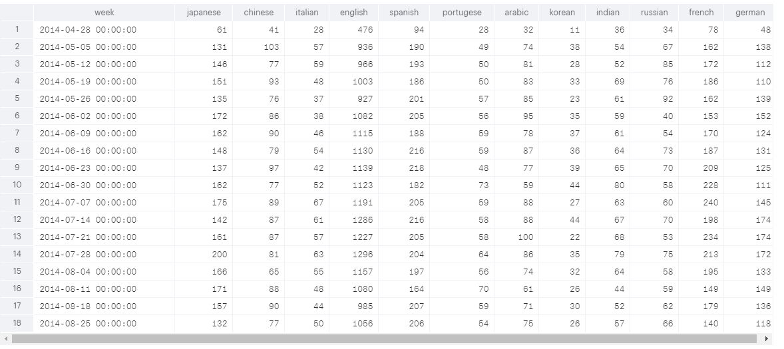

English, French, German and Japanese seem to have the largest drop offs. It may be worthwhile to look at the emails and application versions in those 4 languages to look for bugs or mistranslations.

**User Device by Week**

SELECT COUNT(DISTINCT e.device)

FROM tutorial.yammer_events e

WHERE e.event_type = 'engagement'

AND e.event_name = 'login'

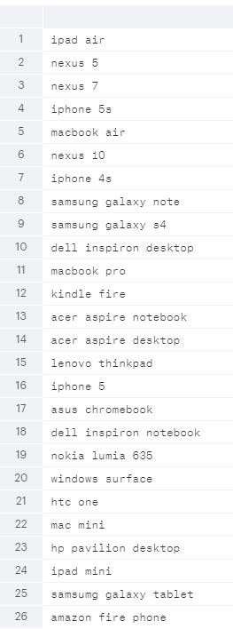

Break down devices by mobile, tablet and computer

SELECT DATE_TRUNC('week', e.occurred_at) AS week,

COUNT(CASE WHEN e.device IN ('iphone 5s', 'iphone 4s', 'samsung galaxy tablet', 'amazon fire phone',

'iphone 5', 'nokia lumia 635', 'htc one', 'samsung galaxy note', 'samsung galaxy s4')

THEN e.user_id ELSE NULL END) AS mobile,

COUNT(CASE WHEN e.device IN ('ipad air', 'nexus 5', 'nexus 7', 'nexus 10', 'kindle fire', 'ipad mini')

THEN e.user_id ELSE NULL END) AS tablet,

COUNT(CASE WHEN e.device IN ('macbook air', 'dell inspiron desktop', 'macbook pro', 'acer aspire notebook',

'acer aspire desktop', 'lenovo thinkpad', 'asus chromebook', 'dell inspiron notebook',

'windows surface', 'mac mini', 'hp pavilion desktop')

THEN e.user_id ELSE NULL END) AS computer

FROM tutorial.yammer_events e

WHERE e.event_type = 'engagement'

AND e.event_name = 'login'

GROUP BY 1

ORDER BY 1

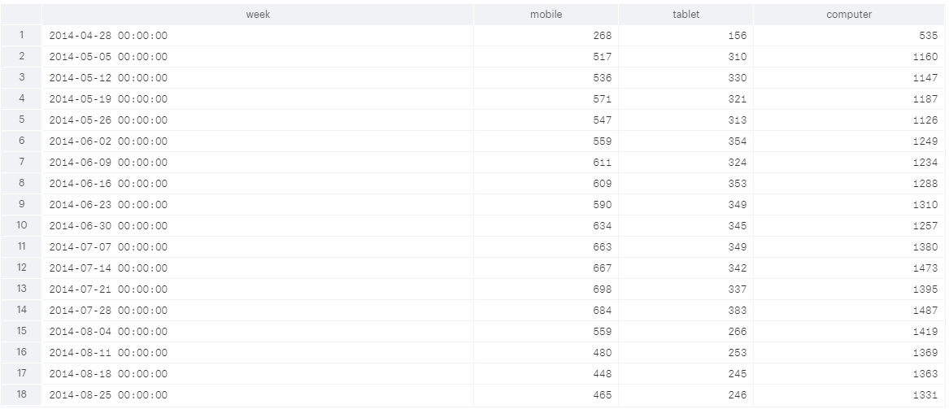

Mobile and tablet login engagement has declined significantly more than computer. Would analyze the application on those platforms first before computer.